|  |  |  |  |
| --- | --- | --- | --- |
| **Term 1**  **5–8** | Students examine a variety of texts across a range of genres and consider how language features and textual conventions influence audience responses. They assess how similar themes, issues and/or ideas are treated and consider relationships between texts, audiences, purposes, genres and contexts. | **Analyse and critically appraise how the conventions of texts influence responses, including:**   * the ways language patterns can create shades of meaning * how responses to texts and genres may change over time and in different cultural contexts * role of the audience in making meaning * how expectations of genres have developed and the effect when those expectations are met or not met, extended or subverted.   **Compare texts from similar or different genres and contexts by:**   * analysing and evaluating how similar themes, issues, ideas and concepts are treated in different texts. | **Task 3: 5% Responding**  **Due T1 W8  In class**  Write an analytical essay based on the content taught, under exam conditions. |

|  |  |  |  |  |  |
| --- | --- | --- | --- | --- | --- |
|  | **MONDAY** | **TUESDAY** | **TUESDAY** | **WEDNESDAY** | **FRIDAY** |
| W5 | Introduce Genre and definition: The categories into which texts are grouped. The term has a complex history within literary theory and is often used to distinguish texts on the basis of their subject matter (for example, detective fiction, romance, science fiction, fantasy fiction), form and structure (for example, poetry, novels, biography, short stories).  Hand out Gestalt Theory and point out theory. Explain that we are going to: Compare texts - how genres influence audience. Analyse each text:  conventions of each genre, language,  structure, style, does the text confirm or challenge conventions of that genre, are the genres challenged, manipulated or subverted. Compare and contrast each genre. Issue of:  **Minority groups** | Continue to Read through Genre in Rod, Wendy and Hugh’s book.  Read the comprehending text there and answer the questions as a placemat with groups | Comparing texts with regard to language, conventions, style, ideas, issues and themes; the role of the audience in meaning-making. | **Minority Groups:**  Hand out Genre political drama and read through excerpt of No Sugar, hand out minority groups  As questions as to whether this texts confirms the genre,  language,  structure,  style,  does the text confirm or challenge conventions of that genre,  are the genres challenged, manipulated or subverted.  Compare and contrast each genre  Hand out Reading Theory Booklet | Watch short you tube clips of Mad Men and discuss  MADMEN (EPISODE WHERE THE AFRICAN AMERICANS DEMANDED A RIGHT)  Placemats to discuss texts in light of Minority groups texts, share with class  Hand out Viewing Theory Booklet |
| W6 | Monday Long Weekend | Hand out film package  Watch Gran Torino  Students fill in work package as they watch film  Reference: Shawshank Redemption  Hand out Viewing Theory Booklet | Watch Gran Torino | Watch Powerpoints on GranTorino Analyse film:  conventions of each genre,  language,  structure,  style,  does the text confirm or challenge conventions of that genre,  are the genres challenged, manipulated or subverted | Listen to Song lyrics on minority groups,  American Pie and Black Eye Peas where is the love  Analyse how minority groups are developed within the lyrics  Read copy of Martin Luther Kings I have a dream speech and anlyse the persuasive speech in terms of the genre of persuasive speeches  Hand out reading Theory Booklet |
| W7 | Read excerpt from  Summer of the 17th Doll  Analyse text:  conventions of each genre,  language,  structure,  style,  does the text confirm or challenge conventions of that genre,  are the genres challenged, manipulated or subverted.  Hand out reading Theory Booklet | Introduce Picture Book and Graphic Novels:  Maus by Art Spiegelman  Analyse text:  conventions of each genre,  language,  structure, style,  does the text confirm or challenge conventions of that genre, are the genres challenged, manipulated or subverted | . Maus by Art Spiegelman  Continue with analysis of Maus  Hand out reading Theory Booklet | *Read excerpt from:*  *Swallow the Air* by Tara June Winch  Analyse text:  conventions of each genre,  language,  structure, style,  does the text confirm or challenge conventions of that genre, are the genres challenged, manipulated or subverted.  Hand out reading Theory Booklet. | Students have this lesson to fill in their booklets |
| W8 | Visual Images  Analyse how visual images portray minority groups and whether these confirm or challenge conventions of that genre, are the genres challenged, manipulated or subverted. | Small groups of students using retrieval charts to analyse texts, for placemats on previous exam questions discussing genre, groups showing this on minority groups, Share | Continue as per period 1 lesson | Discuss analytical essay writing and what the question will be looking for and how to use intertextuality to answer the question | In class essay based on previous exam question on genre |

TASK 3: RESPONDING: In class and at home, maintain a reflective journal for each text covered in which you:• identify any language features and/or generic conventions that impacted on you as a reader/viewer and briefly explain why• evaluate the ways in which textual and language features have shaped your responses to ideas/issues/themes for each genre you have studied• consider the extent to which responses to your chosen texts may differ over time in different cultural contexts.(Your journal must include one entry for each of five or six text types, such as a feature film, a poem, a short play, a documentary, an episode from a sitcom, a cartoon or comic strip.)

Comparing texts with regard to language, conventions, style, ideas, issues and themes; the role of the audience in meaning-making.

THEME/TOPIC: MINORITY GROUPS

1. SPEECH: MARTIN LUTHER KING
2. FILM GRAN TORINO
3. MAD MEN
4. SWALLOW THE AIR
5. MAUS
6. NO SUGAR (PLAY)
7. SUMMER OF THE 17TH DOLL (PLAY)
8. VISUAL IMAGERY

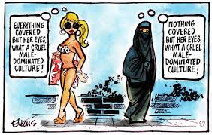 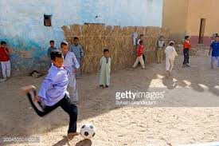

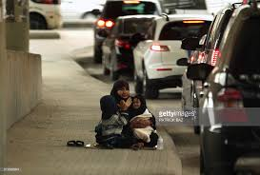 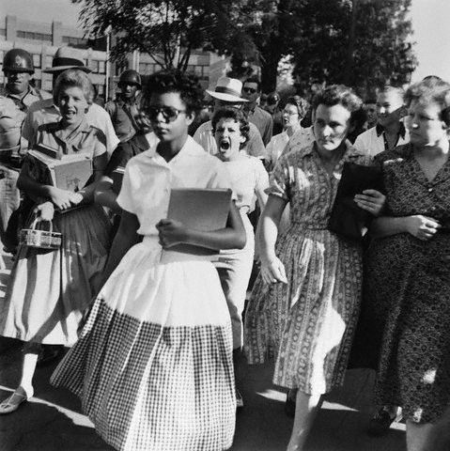

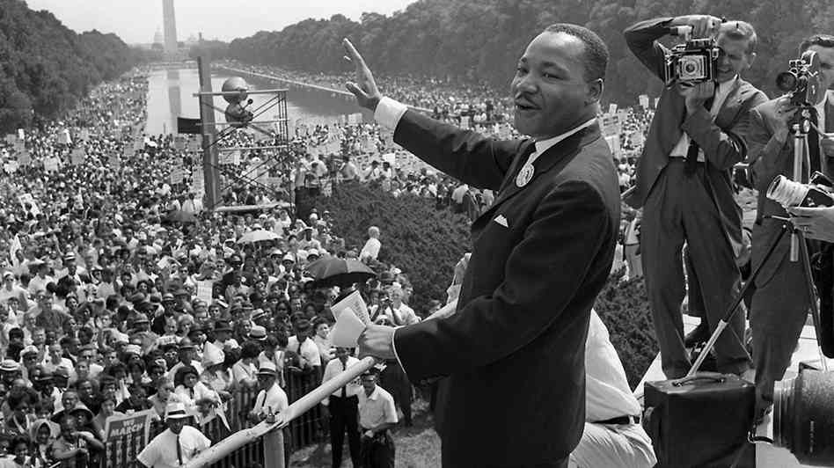

AMERICAN PIE

Don McLean

Verse 1

A long, long time ago...  
American Pie was written in 1971 and the time McLean is going to talk about is the 1950's. This seems like a long time ago because of all the turmoil that occurred in the 60's.

I can still remember how that music used to make me smile.  
McLean's favourite music was that of the 50's.

And I knew if I had my chance, that I could make those people dance, and maybe they'd be happy for a while.  
In the 50's, the major purpose of music was for dancing (sock hops). He wanted to play rock & roll so people could have a good time.

But February made me shiver  
Buddy Holly died on February 3, 1959 in a plane crash in Iowa. He was McLean's hero.

With every paper I'd deliver  
Donny boy's only other job besides song writing was a paper boy.

Bad news on the doorstep, I couldn't take one more step  
This story was obviously on the front page and made McLean freeze in his tracks.

I can't remember if I cried  
He can't remember if he cried.

When I read about his widowed bride  
Holly's wife was pregnant when the accident occurred and soon after had a miscarriage.

But something touched me deep inside  
He was very sad

The day the music died.  
The crash took the lives of three current rock legends: Holly, Richie Valens and the Big Bopper, so now Feb. 3, 1959 is called "The day the music died." The music that died is considered the standard rock & roll songs. The crash was the final blow to this music 'because these three were that only major artists left. Elvis was drafted, Little Richard (or "Little Dick") turned gospel, and Chuck Berry was arrested.

Verse 2

Did you write the book of love?  
"The Book of Love" was a hit in 1968 by the Monotones.

And do you have faith in God above, if the Bible tells you so?  
In 1955, Don Cornell wrote "The Bible Tells Me So" and there is a Sunday School song "Jesus Loves Me," with the line "For the Bible tells me so."

Now do you believe in rock & roll?  
This is from the great song "Do You Believe in Magic?" by the Lovin' Spoonful, written by John Sebastin in 1965. One of the lines is like trying to teach a stranger 'bout rock & roll," and another is "the magic's in the music and the music's in me." The "magic" this Johnny was talking about is the ability of a song to stick in your head. Often songs bring back memories of the past, this is what the magic is.

Can music save your mortal soul?  
Given all that, can music help you get though life? All of these questions ask about life and if God exists.

And, can you teach me how to dance real slow?  
Dancing in the 50's wasn't like it is today. If you danced with someone, you then were committed to them.

Now I know that you're in love with him, because I saw you dancing in the gym.  
Like I said, dancing was serious. McLean caught his love cheating on him.

You both kicked off your shoes  
Reference to a "sock hop."

Man, I dig those rhythm and blues  
He's depressed. There's a style of music for every feeling.

I was a lonely teenage broncin' buck  
allegory for a young teenager

With a pink carnation and a pickup truck  
A pickup truck was a symbol of sexual freedom (and it rhymes with "buck" and "luck"), and Marty Robbins had a hit with "A White sport Coat (And a Pink Carnation) in 1957.

But I knew I was out of luck, the day the music died.  
These old crazy things that worked in the fifty's no longer work, because the 60's brought a new social revolution. Peace Out!

Verse 3

Now for ten years we've been on our own

The music died 1959, McLean more than likely started writing this song around 1969.

And moss grows fat on a rolling stone  
The great Bob Dylan wrote "Like a Rolling Stone" in 1965. This was his first MAJOR change from folk music. In late 1966, Dylan was involved in a motorcycle accident, and hid in his house in Woodstock, NY for a good year, hence the "fat," and the moss shows the time change. Dylan didn't really get his muse back till 1975.

but that's not how it used to be.  
McLean liked Dylan as a folk singer in the early sixties more than his folk-rock style in the mid sixties

When the jester sang for the king and queen  
the jester's Bob Dylan. The king is Peter Seger and the queen is Joan Baez. These were the two big names in folk at the time early '60's). During the Newport Folk Festival in 1963, Dylan was honoured to play his own set and then combine with these two legends to sing his song "Blowin' in the Wind."

In a coat he borrowed from James Dean  
In the Dean movie "Rebel Without A Cause," he wears a red windbreaker. On the cover of the Dylan's "Freewheelin'," he is seen also in a red windbreaker. This cover also resembles a famous picture of Dean. This ties in with the previous line because this album is were Dylan really took off, with such songs as "Blowin' in the Wind" and "A Hard Rain's A-Gonna Fall."

And a voice that came from you and me.  
Dylan was the spokesman for the 60's

Oh, and while the king was looking down  
This could mean two things; Pete Seger remained a traditional folk singer, while Dylan was constantly reinvented himself and therefore became unbelievably popular. This could also be a reference to Elvis (the King of rock and roll), because he joined the U.S. Army

The jester stole his thorny crown  
While Elvis was in the army, Dylan took his spotlight and changed the whole music business. The thorny crown is the price of fame, and is referenced with Jesus's thorny crown

The courtroom was adjourned, no verdict was returned  
This deals with the Kennedy assassination. Lee Harvey Oswald was never convicted because he was murdered.

And while Lennon read a book of Marx  
This is about the Beatles music becoming political. Songs like "Revolution" (1968) (which actually mentions Chairman Mao) "Love Me Do" (1963). Many American adults thought the Beatles were bad for the American youth, especially after Lennon's remark in 1966 about Christianity. He said "Christianity will go. It will vanish and shrink. I needn't argue with that; I'm right and I will be proved right. We're more popular than Jesus now; I don't know which will go first: rock 'n' roll or Christianity."

The quartet practiced in the park  
The quartet was the Beatles (there were four,) and the park thing is Candlestick Park, the place of their last concert. It was practicing because their music would grow after they stopped touring (their first project after this was "Sgt. Pepper" which is considered the best album of all time).

And we sang dirges in the dark, the day the music died.  
A dirge is a funeral song. These songs were for the Kennedy's (John and Robert) and Martin Luther King, all who died in the mid 60's.

Verse 4

Helter Skelter in a summer swelter  
Charles Manson is one of the most dangerous serial killers, In the summer of 1968, he massacred an entire family because of the Beatles song "Helter Skelter," which appeared on the white album. He thought that the Beatles were warning America about the racial conflict and it was "coming down fast." He thought the Beatles were the four angels mentioned in the Book of Revelation in the Bible. Manson wrote the title of the song on the wall in blood after committing the murders. Also, he thought in "Revolution 9" that Lennon was saying "rise" instead of "right," thought the line "They need a damn good whacking" from "Piggies" was telling him to kill people and the "Hollywood Song" in "Honey Pie" was about him because he lived near Hollywood.

The Byrd flew off with to a fallout shelter  
The Byrd's were a popular folk-rock group, with the huge cover of Dylan's "Mr. Tambourine Man," in 1965. One of the members was arrested for possession of marijuana and a fallout shelter was another name for a rehab program. A strange note is that Dylan's "Mr. Tambourine Man" appeared on his "Bringing It All Back Home" record, and on the lower left corner of the cover is a fallout shelter sign.

Eight miles high and falling fast.  
“Eight Miles High" was the first ever psychedelic song, the sound of the guitar was supposed to sound like a saxophone. The falling fast part is probably about the fact that the Byrd's abandoned folk-rock for country music with the album "Sweetheart of the Rodeo," in 1967

Then landed in the foul grass  
Foul grass meaning marijuana.

The players tried for a forward pass  
Here the football metaphor starts. The players are the protesters in the 60's. The forward pass was their movement to change the situation they were in, full of government corruption.

With the jester, on the sidelines in a cast.  
Jester=Dylan. In late 1966, while riding near his house in Woodstock, NY, he briefly glanced into the sun and lost control of his bike. When he went to brake, they locked up on him and sent him flying off the motorcycle. It took him about 9 months to, in which time he very rarely left the house, hence the cast.

Now the half time air was sweet perfume  
Flower Power, groovy baby! Symbolism for marijuana

While sergeants played a marching tune  
Sgt. Pepper, Beatles, 1967, recently named the most influential album of all time. First ever concept album. First to have lyrics printed on the back. First to have a design on the protector of the record. Included an elaborate cover design and cut-outs. As far as the music goes, it had drug references in Lucy in the Sky with Diamonds, sitars, animal sounds and studio trickery.

We all got up to dance, but we never got the chance  
The Beatles helped to start a new kind of music that was meant to be listened and not danced to

because the players tried to take the field  
Players=Protesters. In 1968, at the Chicago Democratic convention, protesters rioted, and some were beaten by the police. It is now known as the days of rage. Also in 1970, at Kent State University, four students were killed by the National Guard in response to their anti-Vietnam protests, which inspired the song "Ohio" by CSN & Neil Young.

The marching band refused to yield  
The Beatles had some anti-violence songs that made protesters think twice about the way they were acting. "All You Need is Love" (1967) says there is a better way then violence, and in "Revolution" (1968) one of the lines is "But when you talk about destruction, don't you know that you can count me out." The Beatles were in no way pro-government (as seen in 1968's "Piggies," which is about Congressmen), but they were against violence.

Do you recall what was revealed, the day the music died.  
As Dr. Evil says in Austin Powers, "Face it, freedom failed" or more accurately, the protests failed. The government is more corrupt now than ever before. McLean wasn't a big 60's fan and here is putting down the efforts of the failed generation.

Verse 5

And then we were all in one place  
Woodstock Performing Arts Festival took place in August in 1969. 400,000 of McLean's generation were there. It took place at Woodstock (actually Bethel) because that's where Dylan was hiding, and they were hoping he would come out and play. Unfortunately he turned it down for the "Isle of Wright" concert.

A generation lost in space  
The moon landing was of course in 1969, David Bowie's "Space Oddity" was released (which was about 'major Tom' who got lost in space), there was a TV show called "Lost in Space" and this is a drug reference, the 60's are generalized by saying everyone in the entire world was on acid.

With no time left to start again  
It took them a whole decade to get to this point, the generation's time was quickly fading. McLean thinks they wasted most of their time on drugs.

So come on Jack be nimble, Jack be quick, Jack flash sat on a candlestick  
"Jumpin' Jack Flash" was a hit for the Rolling Stones. In this song, McJagger compares himself with Jesus. This line comes from the nursery rhyme that has the line "Jack be nimble, Jack be quick, Jack jumps over a candlestick."

because fire is the devil's only friend.  
The Stones sold out to the devil. Their only comeback to the Beatles "Sgt. Pepper" was their album "Their Satanic Majesties Request." Also, their song "Sympathy for the Devil," proves that they were desperate to sell their records Was it really worth celebrating the devil?

Oh, and as I watched him on the stage  
In December of 1969, the Stones attempted another Woodstock, this time at Altamont Speedway. This time it was a free concert, with the Hell's Angel's handling the security. The biggest mistake was paying them in advance, but instead of money, with beer and handfuls of acid. While the Stones were singing "Sympathy for the Devil," an African American man was beaten and stabbed to death by the Hell's Angels. They soon began beating everyone, include a member of the Jefferson Airplane.

My hands were clenched in fists of rage  
He was angry

No angel born in hell could brake that Satan's spell  
"angels born in hell" a.k.a. the "Hell's Angels!" When you have sympathy for the devil, you're asking for trouble.

As the flames climbed high into the night, to light the sacrificial rite  
The Stones were helicoptered out, hence the "climbed high." The sacrifice to the devil was the man's life.

I saw Satan laughing with delight, the day the music died.  
This was the definitive ending of the sixties. The generation that was lost in space was now lost on earth. Before the only violence was between the hippies and the police, now it was amongst themselves. Satan had won, in one final blow.

Verse 6

I met a girl who sang the blues and I asked her for some happy news, but she just smiled and turned away.  
Janis Joplin is most the girl who sang the blues. Her big hits were "Piece of My Heart" and "Me and Bobby McGee." She died of an accidental heroin overdose on October 4, 1970. McLean is still trying to find happiness like in the beginning of the song "Maybe they'd be happy for a while," "That music used to make me smile." (Note the tone of the song is very similar in these to verses) But this time the smile isn't for happiness but regret.

I went down to the sacred store  
Here he's talking about record stores that sold 50's albums.

Where I heard the music years before, but the man said the music wouldn't play  
By the 70's, the 50's music was almost ignored by everyone. Hundreds of great albums were released in the 60's, and it seems that everyone has forgot about the 50's.

And in the streets the children screamed

The youth of America were beaten in the streets especially at the end of the decade.

The lovers cried and the poets dreamed  
In Dylan's "A Hard Rain's A-Gonna Fall," he says: "I met one man he was wounded in love, I met another man he was wounded in hatred," showing that love hurts sometimes as much as hate.

But not a word was spoken. The church bells all were broken.  
Again in "A Hard Rain...," the line is "I saw ten thousand talkers whose tongues were all broken." Simon and Garfunkel had a hit with "Sound of Silence." The church bells all were broken shows that people have forgotten God. All things are so sacred are gone, love, faith, happiness, peace. In Dylan's "It's Alright Ma (I'm Only Bleeding)," one verse goes: Disillusioned words like bullets bark . As human gods aim for their mark . Made everything from toy guns that spark . To flesh-coloured Christs that glow in the dark . It's easy to see without looking too far. That not much Is really sacred. McLean isn't the only one that feels this way. He was obviously a religious man, and is very disappointed that they have abandoned God.

And the three men I admire most, the Father, Son and Holy Ghost  
The trinity of God, McLean was Catholic.

They caught the last train for the coast.  
God has left. Time magazine even featured a cover story "Is God Dead?" The generation has failed, and "with no time left to start again." It was now up to the next generation to put things right

The day the music died. And we were singing....  
References to the Kennedy's (him being the king and his wife the queen),

Refrain

So bye, bye Miss American Pie  
McLean was dating one of the Miss America contestants during one of the pageants. Also the "American Pie" part is a symbol of the American Dream (at least of the 50's), it was also the name of the plane that crashed and killed Holly

Drove my Chevy to the levee but the levee was dry  
The American automobile was the Chevy. The levee business shows that America wasn't fertile anymore (at least in the sense of music).

And them good old boys were drinking whiskey and rye singing "This will be the day that I die, this will be the day   
that I die."  
The traditional Americans are depressed with the current lifestyle (60's). The song comes from Buddy Holly's "That'll be the day," that eventually says "that I die."

**"Where Is The Love?"**

What's wrong with the world, mama  
People livin' like they ain't got no mamas  
I think the whole world addicted to the drama  
Only attracted to things that'll bring you trauma  
  
Overseas, yeah, we try to stop terrorism  
But we still got terrorists here livin'  
In the USA, the big CIA  
The Bloods and The Crips and the KKK  
  
But if you only have love for your own race  
Then you only leave space to discriminate  
And to discriminate only generates hate  
And when you hate then you're bound to get irate, yeah  
  
Madness is what you demonstrate  
And that's exactly how anger works and operates  
Man, you gotta have love just to set it straight  
Take control of your mind and meditate  
Let your soul gravitate to the love, y'all, y'all  
  
People killin', people dyin'  
Children hurt and you hear them cryin'  
Can you practice what you preach?  
Or would you turn the other cheek?  
  
Father, Father, Father help us  
Send some guidance from above  
because people got me, got me questionin'  
Where is the love (Love)  
  
Where is the love (The love)  
Where is the love (The love)  
Where is the love, the love, the love  
  
It just ain't the same, old ways have changed  
New days are strange, is the world insane?  
If love and peace are so strong  
Why are there pieces of love that don't belong?  
  
Nations droppin' bombs  
Chemical gasses fillin' lungs of little ones  
With ongoin' sufferin' as the youth die young  
So ask yourself is the lovin' really gone  
  
So I could ask myself really what is goin' wrong  
In this world that we livin' in people keep on givin' in  
Makin' wrong decisions, only visions of them dividends  
Not respectin' each other, deny thy brother  
A war is goin' on but the reason's undercover  
  
The truth is kept secret, it's swept under the rug  
If you never know truth then you never know love  
Where's the love, y'all, come on (I don't know)  
Where's the truth, y'all, come on (I don't know)  
Where's the love, y'all

People killin', people dyin'  
Children hurt and you hear them cryin'  
Can you practice what you preach?  
Or would you turn the other cheek?  
  
Father, Father, Father help us  
Send some guidance from above  
because people got me, got me questionin'  
Where is the love (Love)  
  
Where is the love (The love)?  
Where is the love (The love)?  
Where is the love (The love)?  
Where is the love (The love)?  
Where is the love (The love)?  
Where is the love (The love)?  
Where is the love, the love, the love?  
  
I feel the weight of the world on my shoulder  
As I'm gettin' older, y'all, people gets colder  
Most of us only care about money makin'  
Selfishness got us followin' the wrong direction  
  
Wrong information always shown by the media  
Negative images is the main criteria  
Infecting the young minds faster than bacteria  
Kids wanna act like what they see in the cinema  
  
Yo', whatever happened to the values of humanity  
Whatever happened to the fairness and equality  
Instead of spreading love we're spreading animosity  
Lack of understanding, leading us away from unity  
  
That's the reason why sometimes I'm feelin' under  
That's the reason why sometimes I'm feelin' down  
There's no wonder why sometimes I'm feelin' under  
Gotta keep my faith alive 'til love is found  
Now ask yourself  
  
Where is the love?  
Where is the love?  
Where is the love?  
Where is the love?  
  
Father, Father, Father, help us  
Send some guidance from above  
because people got me, got me questionin'  
Where is the love?  
  
Sing with me y'all:  
One world, one world (We only got)  
One world, one world (That's all we got)  
One world, one world  
And something's wrong with it (Yeah)  
Something's wrong with it (Yeah)  
Something's wrong with the wo-wo-world, yeah  
We only got  
(One world, one world)  
That's all we got  
(One world, one world)